(Source: <https://slideplayer.com/slide/4273366/>)

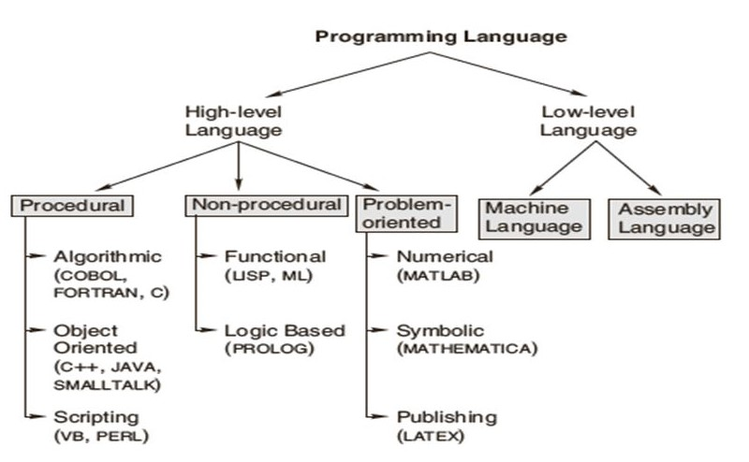

Figure 1. Category of Programming Language

Using the above hierarchical diagram, introduce the basic classification of computer programming languages, and provide several examples. Remember to use appropriate signaling words when referring to the diagram within the text, and give the diagram a numbering with a suitable caption.